SOFTWARE DESIGN SPECIFICATIONS

for
Glamspace: Your Beauty Hub
Version 1.0 approved
Prepared by LAVENDA OKEY ALELA
KCA UNIVERSITY
DBIT 506
23/06441
Date: 21/02/2025

Table of Contents
SOFTWARE DESIGN SPECIFICATIONS 1
for 1
1. Introduction 3
1.1 Purpose 3
1.2 System Overview 3
1.3 Design Map 3
1.4 Definitions and Acronyms 3
2. Design Considerations 3
2.1 Assumptions 4
2.2 Constraints 4
2.3 System Environment 4
2.4 Design Methodology 4
2.5 Risks and Volatile Areas 4
3. Architecture 5
3.1 Overview 5
3.2 Subsystem, Component, or Module 1 ...N 5
3.3 Strategy 1...N 5
4. Database Schema 5
4.1 Tables, Fields, and Relationships 5
4.2 Data Migration 6
5. High-Level Design 7
5.1 Salon Search Form 7
5.2 User Interface Modifications 9
5.3 Workflow Sub-Processes 9
5.4 Process-Specific Reporting 10
6. Low-Level Design 11
6.1 Module 1...N 11
7. User Interface Design 11
7.1 Application Controls 11
7.2 Screen 1...N 11
8. Appendix A: Project Timeline 12

Introduction

1.1 Purpose
This document provides the detailed design for the Glamspace: Your Beauty Hub system, a digital platform for locating salons and barbershops, comparing services and prices, and reading reviews. The design is based on the requirements outlined in the Software Requirements Specification (SRS) for the project.

1.2 System Overview
The Glamspace system is a web-based application that allows users to search for nearby salons and barbershops, compare services and prices, and read reviews. The system will include a location-based search, service and price comparison, and a review and rating system. The system will be developed using Visual Basic .NET for the backend and Microsoft Access for the database.

1.3 Design Map
This document outlines the high-level and low-level design of the Glamspace system. It includes the architecture, database schema, user interface design, and detailed module descriptions. The design is broken down into subsystems, components, and modules to ensure clarity and ease of implementation.

1.4 Definitions and Acronyms
- SRS: Software Requirements Specification
- UI: User Interface
- DB: Database
- VB.NET: Visual Basic .NET
- SQL: Structured Query Language

Design Considerations

2.1 Assumptions
- Users will have access to a stable internet connection.
- Salon owners will provide accurate and up-to-date information about their services.
- External mapping services (e.g., Google Maps) will be available for location-based search functionality.

2.2 Constraints
- The system must be developed using Visual Basic .NET and Microsoft Access.
- The system must be compatible with Windows operating systems.
- The system must adhere to data security and privacy regulations.

2.3 System Environment
- Hardware Platform: Standard PC or laptop with internet access.
- Operating System: Windows 10 or later.
- Software: Visual Studio, Microsoft Access, and a web browser (Chrome, Firefox, or Edge).

2.4 Design Methodology
The design will follow an Agile methodology, with iterative development and regular stakeholder feedback. The system will be broken down into modules, and each module will be developed, tested, and integrated incrementally.

2.5 Risks and Volatile Areas
- Database Performance: Potential challenges with database performance due to salon volume and user data.
- Integration with External Services: Risks associated with integrating external mapping services for location-based search.
- Data Security: Ensuring user data is stored securely and complies with data protection regulations.

Architecture

3.1 Overview
The Glamspace system is designed as a three-tier architecture:
- Presentation Layer: Handles the user interface and user interactions.
- Business Logic Layer: Manages the core functionality, such as search, comparison, and review systems.
- Data Layer: Stores and retrieves data from the database.

3.2 Subsystem, Component, or Module 1 ...N
- User Management Module: Handles user registration, login, and profile management.
- Salon Management Module: Allows salon owners to register their salons and manage their profiles.
- Search Module: Implements location-based search and service comparison functionality.
- Review Module: Manages the review and rating system for salons.

3.3 Strategy 1...N
- Modular Design: The system is broken down into modules to ensure scalability and ease of maintenance.
- Iterative Development: The system will be developed in iterations, with regular feedback from stakeholders.

Database Schema

Tables, Fields, and Relationships

4.1.1 Databases
- Glamspace DB: Production database.
- Glamspace Test DB: Development and testing database.

4.1.2 New Tables
- Users: Stores user information (e.g., username, password, email).
- Salons: Stores salon information (e.g., name, location, services).
- Reviews: Stores user reviews and ratings for salons.
    - New fields(s)
TABLE NAME | FIELD NAME | DATA TYPE | ALLOWS NULL | FIELD DESCRIPTION
Users | User ID | Int | No | Unique user ID
Users | Username | Varchar(50) | No | User’s username
Salons | Salon ID | Int | No | Unique salon ID
Salons | Location | Varchar(100) | No | Salon location
Barbershops | Barber ID | Int | No | Unique barbershop ID
Barbershops | Location | Varchar(100) | No | Barbershop location
Reviews | Review ID | Int | No | Unique review ID
Reviews | Rating | Int | No | User rating (1-5)

Fields Change(s)
- No changes to existing fields are required at this stage.

All Other Changes
- No additional changes are required at this stage.

4.2 Data Migration
- No data migration is required as this is a new system.

High-Level Design

5.1 Salon Search Form
The Salon Search Form is the primary interface for users to search for salons and barbershops. It will include the following elements:
- Search Bar: users can enter their location or search for specific services (e.g., haircuts, manicures).
- Filters: Users can filter results by price range, ratings, and services offered.
- Interactive Map: Displays the locations of salons and barbershops based on the user's search criteria.
- Results List: Displays a list of salons with basic information (e.g., name, rating, distance).
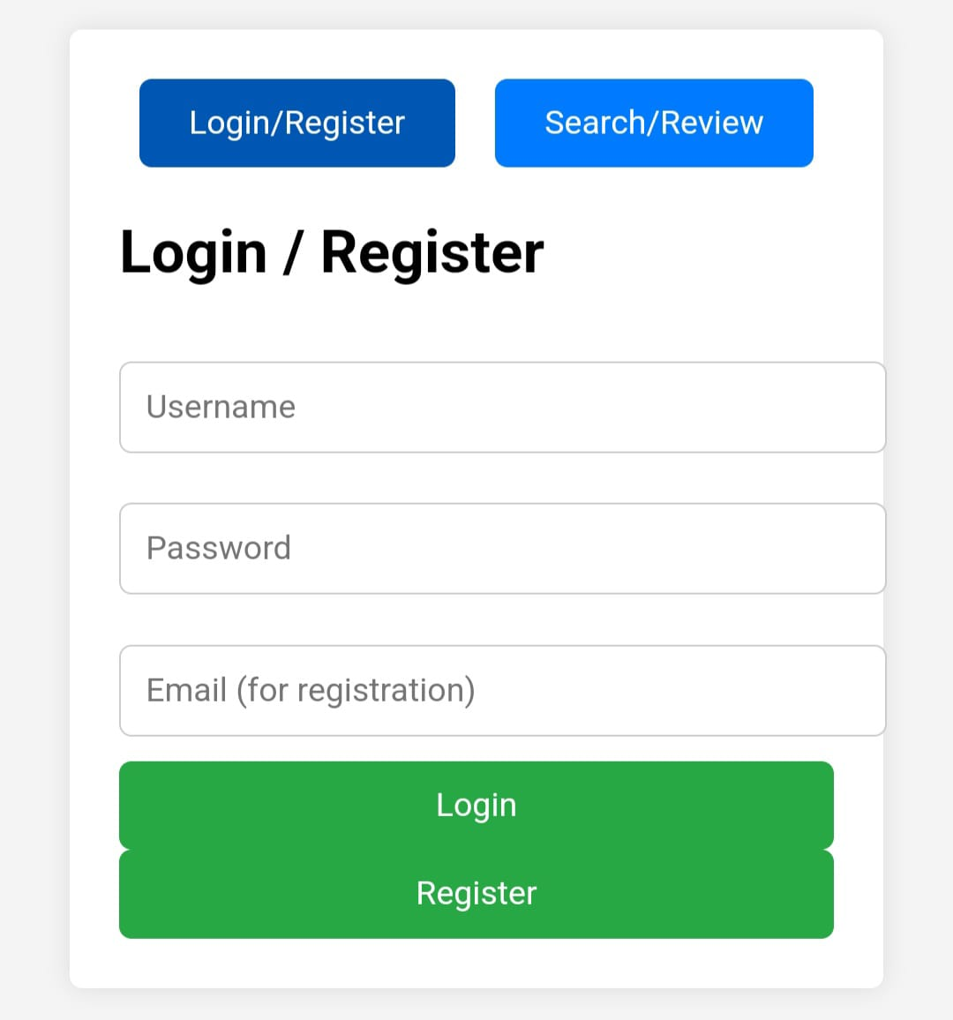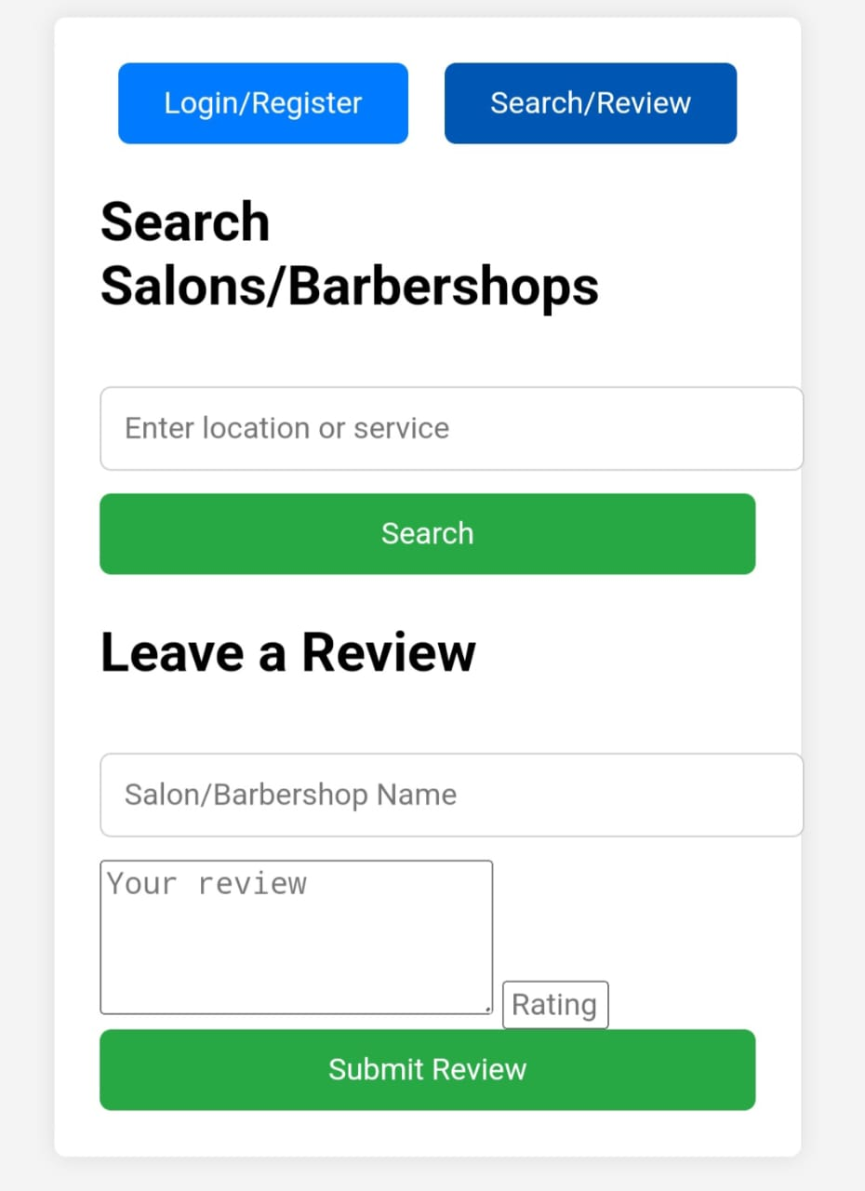
Key Features:
- Users can click on a salon in the list or map to view detailed information.
- The form will dynamically update search results as filters are applied.

5.2 User Interface Modifications
The following modifications will be made to the user interface to improve usability and functionality:
- Navigation Bar:
  - A consistent navigation bar will be present on all screens, allowing users to easily access the search form, their profile, and reviews.
  - The navigation bar will include a Home button, Search button, and Profile button.
- Salon Details Page:
  - The salon details page will display comprehensive information about a selected salon, including:
    - Services offered
    - Pricing
    - Operating hours
    - Contact information
    - User reviews and ratings
  - Users can leave reviews and ratings directly from this page.
- Responsive Design:
  - The interface will be optimized for both desktop and mobile devices, ensuring a seamless user experience across platforms.
- Error Handling:
  - Clear error messages will be displayed if a user enters invalid data (e.g., an invalid location or search term).

5.3 Workflow Sub-Processes
The Glamspace system will include the following workflow sub-processes to manage user interactions and system operations:
- User Registration Workflow:
  - Step 1: The user enters their details (e.g., name, email, password).
  - Step 2: The system validates the data and checks for duplicate accounts.
  - Step 3: The user receives a confirmation email to verify their account.
  - Step 4: Once verified, the user can log in and access the system.
- Salon Registration Workflow:
  - Step 1: The salon owner enters their business details (e.g., name, location, services).
  - Step 2: The system validates the data and checks for duplicate entries.
  - Step 3: The Salon owner receives a confirmation email.
  - Step 4: Once verified, the salon is added to the system and becomes searchable.
- Review Submission Workflow:
  - Step 1: The user selects a salon and clicks the "Leave a Review" button.
  - Step 2: User enters their review and rating.
  - Step 3: System validates the review (e.g., checks for inappropriate language).
  - Step 4: The review is published and displayed on the salon's details page.
- Search Workflow:
  - Step 1: User enters a location or search term in the search bar.
  - Step 2: System retrieves matching salons from the database.
  - Step 3: Results are displayed in a list and on the interactive map.
  - Step 4: The user can apply filters to refine the results.

5.4 Process-Specific Reporting
The system will generate the following reports to provide insights into user and salon activity:
- User Activity Report:
  - Tracks user searches, reviews, and interactions with the system.
  - Helps identify popular services and user preferences.
- Salon Performance Report:
  - Tracks salon ratings, reviews, and search visibility.
  - Helps salon owners understand their performance and areas for improvement.
- System Usage Report:
  - Tracks overall system usage, including the number of searches, registrations, and reviews.
  - Helps administrators monitor system performance and identify trends

6. Low-Level Design

6.1 Module 1...N
- User Management Module: Handles user registration, login, and profile updates.
- Salon Management Module: Allows salon owners to register their salons and update their profiles.
- Search Module: Implements location-based search and service comparison functionality.
- Review Module: Manages the review and rating system for salons.

7. User Interface Design

7.1 Application Controls
- The system will have a consistent look and feel across all screens.
- Common controls include a navigation bar, search bar, and interactive map.

7.2 Screen 1...N
- Home Screen: Displays the search bar and interactive map.
- Search Results Screen: Displays a list of salons based on the user's search criteria.
- Salon Details Screen: Displays detailed information about a selected salon, including reviews and ratings.

8. Appendix A: Project Timeline
WEEKS | DAYS | PHASE | TASK | DELIVERABLE
Week 1 | 1-5 | Project planning | Requirement gathering | Project plan document
Week 2 | 6-10 | Analysis | User requirement analysis | Requirement document
Week 3 | 11-15 | Database design | Database design | Database schema
Week 4 | 16-20 | UI design | UI mockups | UI design prototype
Week 5-6 | 21-30 | Core development | Core functionality coding | Basic working system
Week 7 | 31-35 | Feature development | Search functionality | Complete system features
Week 8 | 36-40 | Testing | Unit testing, bug fixing | Test result document
Week 9 | 41-45 | System Integration | User acceptance testing | Test completion report
Week 10 | 46-50 | Deployment | System deployment | Final system

